Appian Interview Experience
Product Engineer (On-Campus Placement)
– Rakshitha T

About Appian:
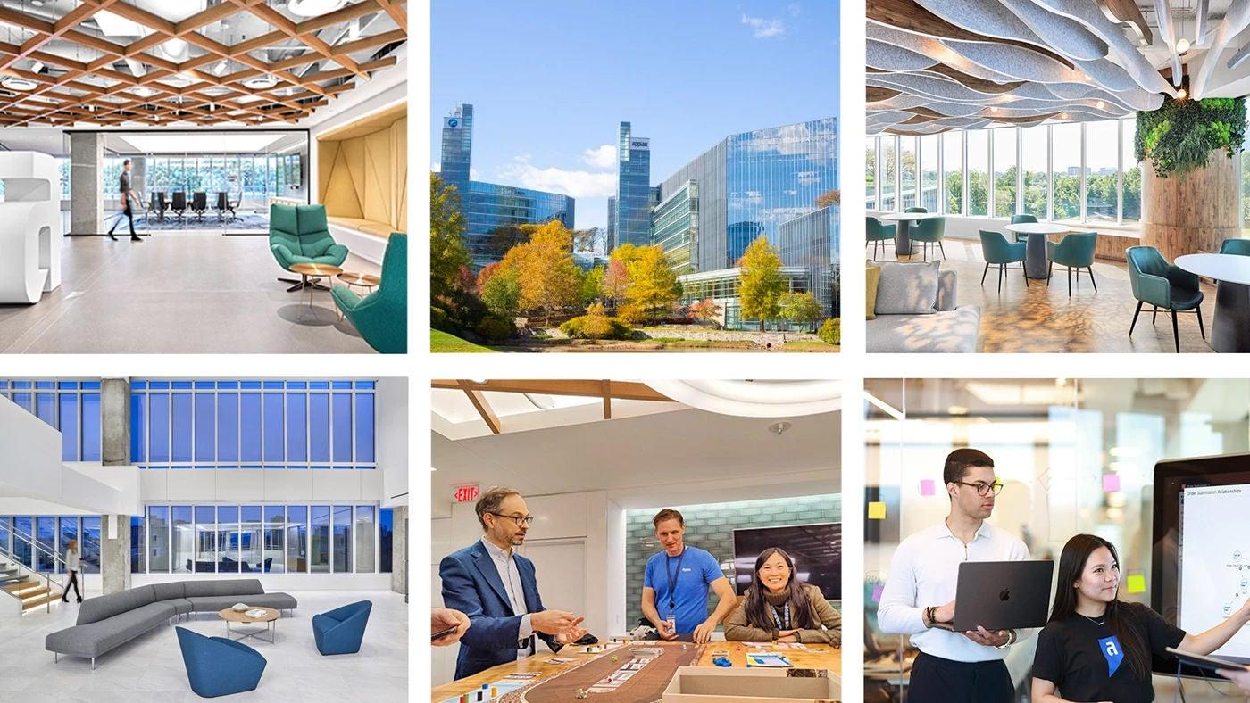

Appian is a global enterprise software company that provides a low-code automation platform to help organizations design, automate, and optimize business processes.
The platform integrates workflow automation, data fabric, AI, and case management, enabling companies to rapidly build scalable enterprise applications.

Selection Process

1️ Technical Online Test

2️ Technical Interview – Round 1

3️ Managerial / Leadership Round (US Head) – Round 2

4️ HR Round – Round 3
All three interview rounds were conducted on the same day after shortlisting from the online test.

Technical Online Test
Focus: DSA (3–4 Coding Questions)
The online assessment was purely technical and DSA-focused.

Topics Covered:
- Arrays
- Strings
- Recursion
- Sorting
- Hashing
- Time & Space Complexity
The questions were easy - medium level and required clear logic building.
Strategy that worked for me:
- Started with brute-force approach
- Clearly optimized step-by-step
- Paid attention to edge cases
- Managed time effectively
Shortlisted candidates moved to interviews.

Round 1: Technical Interview (Core + Resume + OOPS)
Duration: ~40–45 minutes
This round was conducted offline.

🔹 Part 1 – Resume Deep Dive (First 20 Minutes)
The interviewer spent significant time discussing my resume:
- Detailed explanation of my projects
- Tech stack used
- Architecture decisions
- Challenges faced
- My leadership role as President of IEEE WIE
- Research wing initiatives under IEEE
They were particularly impressed with:
- My research initiatives
- My club leadership experience
- How I balanced technical and organizational responsibilities
They evaluated:
- Depth of understanding
- Ownership
- Communication clarity
- Real contribution vs superficial involvement

🔹 Part 2 – OOPS (Python Focus) (Next 20 Minutes)
They asked me which language I was comfortable with. I chose Python.
Interestingly:
- They already had a printed sheet of OOPS questions in Python.
- I was asked to write code on paper in front of them.
- It was a very basic fill in the blanks type of question. There were pre-defined Classes and I was asked to write functions for those classes.

OOPS Topics Covered:
- Classes and Objects
- Inheritance
- Polymorphism
- Encapsulation
- Constructors
- Method Overriding
- Practical implementation scenarios
They checked:
- Concept clarity
- Syntax awareness
- Logical structuring
- Clean code thinking
This round tested fundamentals more than complexity.

Round 2: Managerial / Leadership Round
(Google Meet with US Head – Conducted at CUIC)
This round was more conversational.
Questions asked:
- Why do you want to join Appian?
- What are your future career plans?
- Do you have any other offers?
- What motivates you?
I clearly explained:
- My interest in product-building
- My long-term goal of becoming a Product Manager
- How Product Engineering at Appian gives strong product exposure
They appreciated:
- Clarity of vision
- Honest communication
- Long-term alignment

Round 3: HR Round
This round focused on:
- Role explanation
- Offer intention confirmation
I mentioned that:
I aim to transition into Product Management in the future, and starting as a Product Engineer at Appian is the perfect path to build strong technical-product foundations.
The HR appreciated the clarity and ambition.

My USP (What Made Me Stand Out)
Student Business Card with QR Code
I had a personal student business card that included:
- My name & role
- A QR code linking directly to my resume
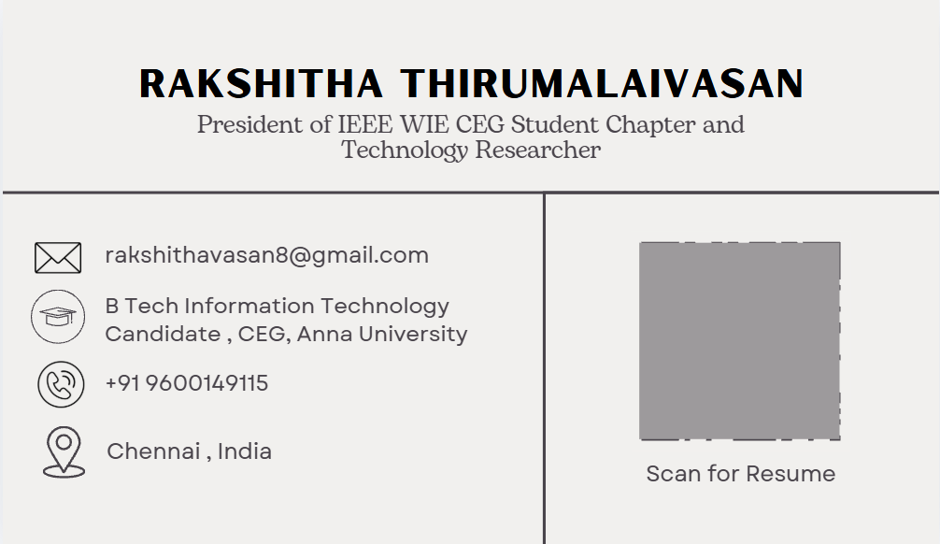
When they scanned it and saw the resume instantly, it created a strong first impression.

It reflected:
- Professionalism
- Branding mindset
- Attention to detail
- Product thinking
This small detail left a memorable impact.

Key Takeaways from My Experience

1️ Be Very Clear About Your Resume
They can question anything mentioned.
Never bluff.

2️ Fundamentals > Fancy Knowledge
OOPS clarity mattered more than advanced frameworks.

3️ Leadership Matters
My role as IEEE WIE President and research initiatives added strong weight.

4️ Career Clarity Impresses
Having a long-term goal (PM path) showed maturity.

5️ Personal Branding Helps
Something as simple as a QR resume card can differentiate you.

Preparation Strategy

DSA:
- Solved topic-wise problems
- Practiced neetcode.io 150 questions
- Focused on explaining approach verbally

OOPS:
- Practiced implementing concepts in Python
- Reviewed inheritance, overriding, polymorphism deeply

Resume:
- Prepared explanations for every single bullet point
- Prepared impact statements for each project
- Don't put anything on your resume that you can't vouch for or explain.

Final Advice
- Start preparation early
- Master fundamentals
- Build leadership exposure
- Be authentic
- Think long-term
- Add small differentiators
Preparation + Clarity + Personal Branding = Strong Impact
I hope this helps you crack your next interview.
Feel free to reach out for any queries!

